Experiment -1.1

|  |  |  |
| --- | --- | --- |
| **Student Name:** | Akansh Arya | **UID:** 22BDO10027 |
| **Branch:** | CSE(DEVOPS) | **Section/Group:** 22BCD-1 A |
| **Semester:** | 4th | **Date of Performance:**17-01-24 |
| **Subject Name:** | Git and GitHub | **Subject Code:** 22CSH-293 |

1. **Aim of the practical:** Install Git and creating a repository.
2. **Task to be done:** Download Git for Windows and make a repository.
3. **Steps for experiment: -**

1) Visit the official Git website: [https://git-scm.com/downloads.](https://git-scm.com/downloads)

2) Click the download link for Windows and allow the download to complete.

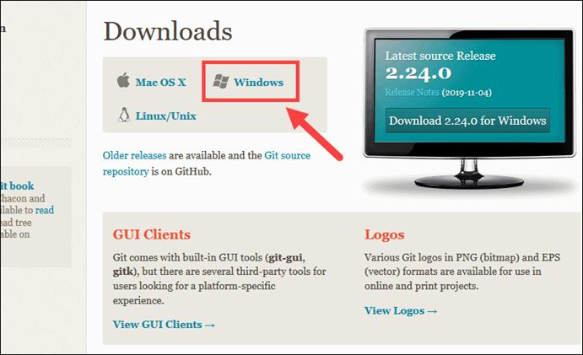

1. Double-click the downloaded file to extract and launch the installer.
2. Allow the app to make changes to your device by clicking **Yes** on the User Account Control dialog that opens.
3. The installer will ask for an installation location. Leave the default, unless you have

reason to change it, and click **Next**.

1. The installer will offer to create a start menu folder. Click **Next**.
2. Select a text editor you’d like to use with Git. Use the drop-down menu to select Notepad++ (or whichever text editor you prefer) and click **Next**.
3. The next step allows you to choose a different name for your initial branch. The default is 'master.' Unless you're working in a team that requires a different name, leave the default option and click **Next.**
4. Choose the [terminal emulator](https://phoenixnap.com/glossary/terminal-emulation) you want to use. The default MinTTY is recommended, for its features. Click **Next**.
5. The installer now asks what the **git pull** command should do. The default option is recommended unless you specifically need to change its behavior. Click **Next** to continue with the installation.
6. Next you should choose which credential helper to use. Git uses credential helpers to fetch or save credentials. Leave the default option as it is the most stable one, and click **Next**.
7. Depending on the version of Git you’re installing, it may offer to install experimental features. At the time this article was written, the options to include support for pseudo controls and a built-in file system monitor were offered. Unless you are feeling adventurous, leave them unchecked and click **Install**.
8. Once the installation is complete, tick the boxes to view the Release Notes or Launch Git Bash, then click **Finish**.

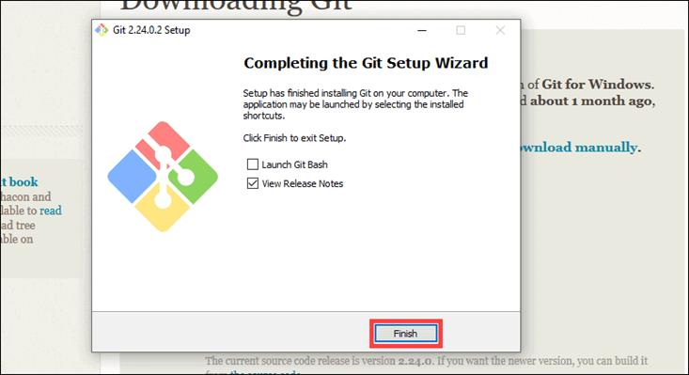

# How to Launch Git in Windows

* Git has two modes of use – a **bash scripting shell** (or command line) and a **graphical user interface** (GUI). To launch **Git GUI** open the **Windows Start** menu, type **Git GUI**and press **Enter** (or click the application icon).
* Connect to a Remote Repository. You need a GitHub username and password for this step.

## Create a Test Directory

* Create a new test directory (folder) by entering the following:

**mkdir first**

* Change your location to the newly created directory

**cd first**

### Configure GitHub Credentials

Configure your local Git installation to use your GitHub credentials by entering the following: git config --global user.name "your github username here"

git config --global user.email "your email address here"

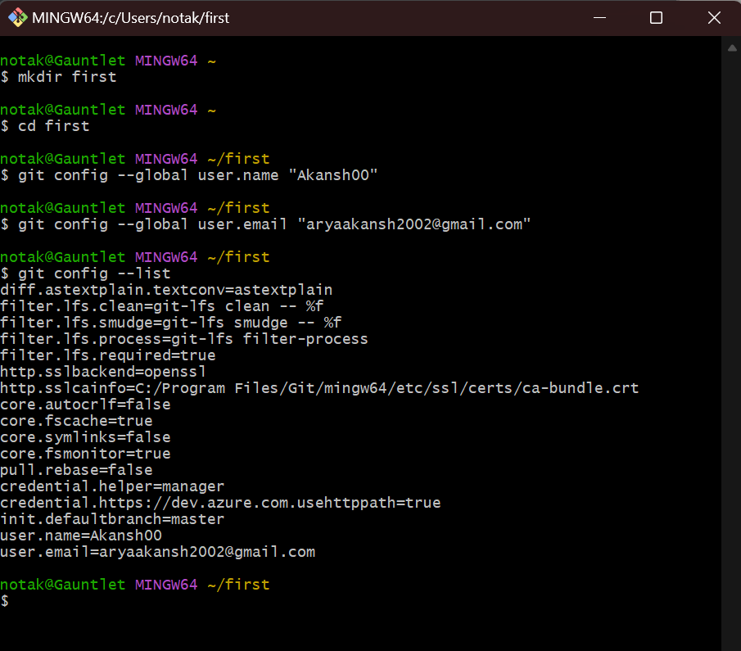

### Clone a GitHub Repository

Go to a repository on GitHub. Open the drop-down menu of **Code**. Copy the **URL for cloning over HTTPS**.

Switch to **Git Bash** window, and enter the following:

git clone (paste the URL of the repository here)

After its done downloading the contents the cloning process is complete.

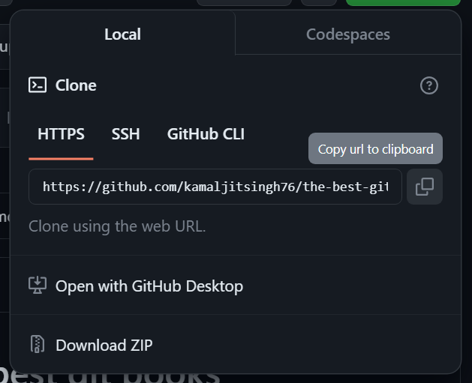

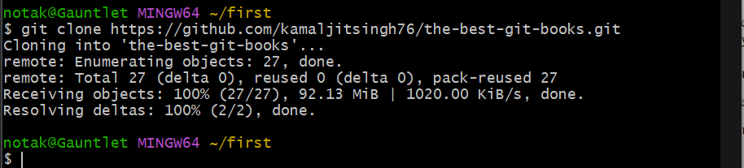



### Creating Repository on GitHub

* 1. After successful login into your account. Click on the option (+) to add new repository to your account.

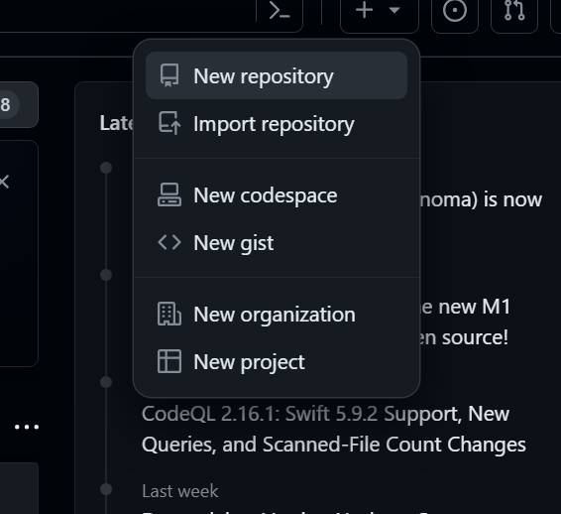

* 1. After clicking **new repository** option, we will have to initialize some things like, **naming our project**, choosing the **visibility** etc. After performing these steps click **Create Repository** button.

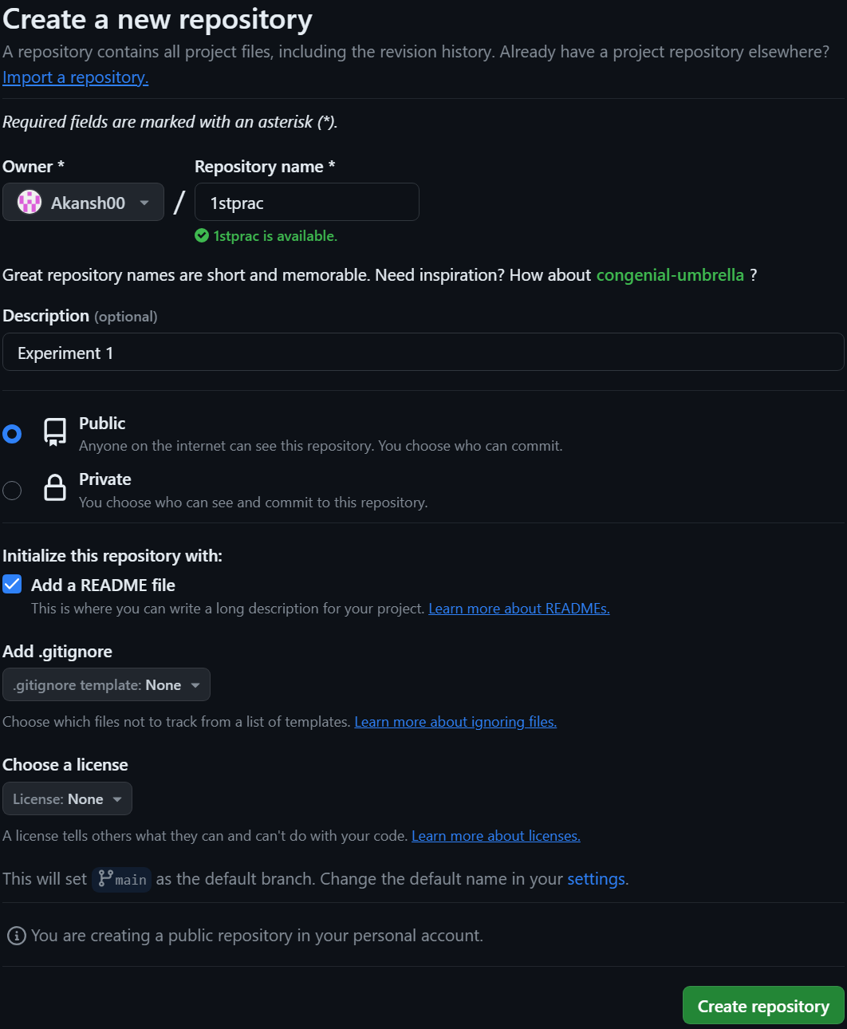

* 1. After clicking the button, we will be directed to below page. Right now the only file we have is a readme file.

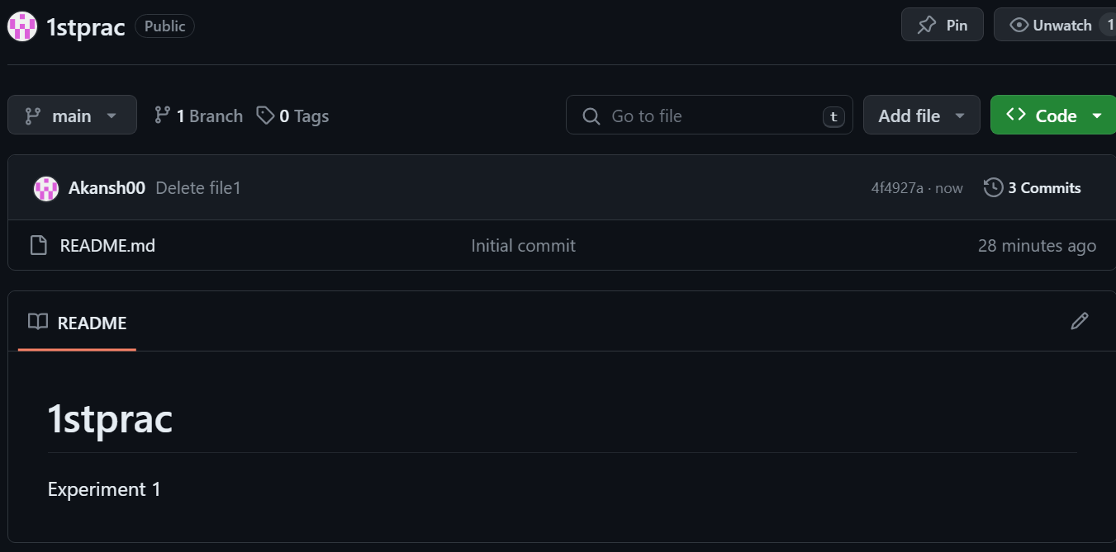

* 1. Now click on the “Add file” and then on “Create new file”, give a name to the file click on “Commit changes”.

# 

# 

We have successfully created a repository.

# Learning outcomes (What I have learnt):

* 1. Learnt about GitHub.
  2. Learnt about Git and how to install it.
  3. Learnt about various git commands that can be applied on Git Bash.
  4. Learnt about how to create repositories.
  5. Learnt about how to clone repositories.
  6. Learnt about how to create files in a repository.

**Evaluation Grid (To be created as per the SOP and Assessment guidelines by the faculty):**

|  |  |  |  |
| --- | --- | --- | --- |
| Sr. No. | Parameters | Marks Obtained | Maximum Marks |
| 1. |  |  |  |
| 2. |  |  |  |
| 3. |  |  |  |
|  |  |  |  |